

Out of the Box CPLD Programmer

Last Updated 5/16/2019

# Table of Contents

Overview 3

Device Connections 3

Installing Drivers 4

Installing FTDI Drivers 4

Installing Quartus Drivers 4

Using the Programmer 5

Opening the Quartus Programmer Window 5

Special Note Do Not Use Auto Detect 6

Hardware Setup 6

Programming 7

# Overview

The Out of the Box CPLD Programmer is a low-cost alternative to the Altera ByteBlaster II as well as the Terasic variant. The Out of the Box CPLD Programmer will only work with 3.3V devices and is intended to pair specifically with the Out of the Box Development Boards.

The CPLD programmer contains very little hardware. The programmer consists only of an FT2232H USB IC and its supporting components. This FTDI device contains a JTAG peripheral which is used for programming and generally interfacing with the CPLD. The software utilized for programming was developed by InPro Plus LLC and is provided on their project webpage marsohod.org. marsohod.org is a self-described “Open Source Hardware Project”. Marsohod generously provides software such as their MBFTDI project as open source.

## Device Connections

The below image shows the cable connections between the Out of the Box CPLD Programmer and Out of the Box MAX V Development Board. The cable will always be oriented correctly as long as the cable is extending out off the boards not over them. In the below image, the red stripe also correctly indicates the pin 1 positions. So, this is the truly correct orientation. This connection scheme also applies to the newer MXDB platform.

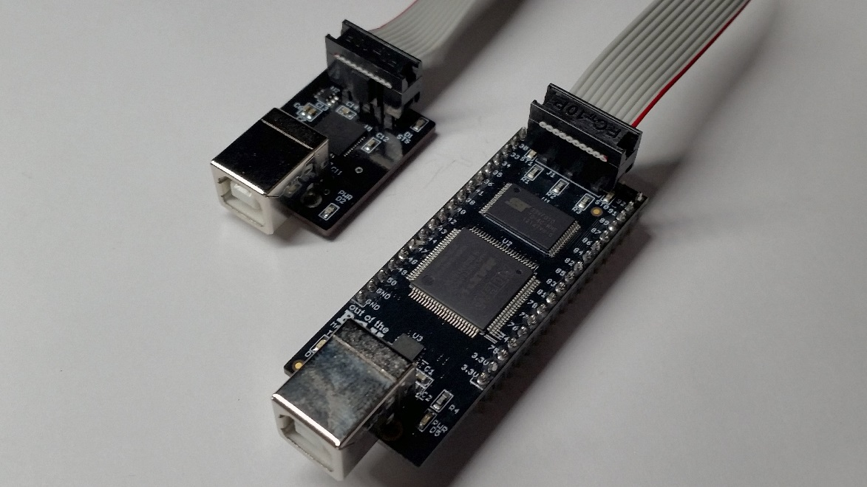

# Installing Drivers

Before the programmer can be used the device drivers must be downloaded and put into the appropriate directories.

## Installing FTDI Drivers

The CPLD programmer uses an FTDI USB device to communicate over JTAG. Install the provided FTDI drivers via this [link](http://www.ftdichip.com/Drivers/CDM/CDM21228_Setup.zip) to the Windows setup executable. The main driver page can be found [here](http://www.ftdichip.com/Drivers/D2XX.htm).

## Installing Quartus Drivers

Provided with this document is a driver for interfacing the CPLD programmer directly with Quartus (**jtag_hw_mbftdi_blaster64.dll**). Place this file in the appropriate Quartus directory structure such as below example.

**C:\altera_lite\16.0\quartus\bin64**

The version “16.0” will vary based on version installed on the machine, and the base directory will be whatever was specified at the time of the Quartus install. The C drive is the default location.

# Using the Programmer

The Out of the Box CPLD Programmer integrates directly with Quartus through the use of the Programmer window.

## Opening the Quartus Programmer Window

* The Quartus Programmer is called by the  button on the toolbar. A window will pop up like that of below

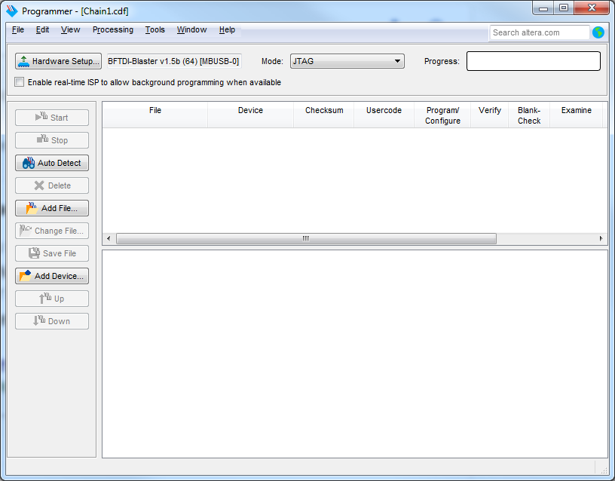

## Special Note Do Not Use Auto Detect

The  button on the Quartus Programmer Window is not supported! Trying to use this feature will lock up the Quartus Programmer Window. Do not use it!

## Hardware Setup

To use the CPLD Programmer the device must be first selected in the Quartus Programmer Window.

If the programming hardware is not recognized before opening the Quartus Programmer Window,  will be displayed. To select the programming hardware press Hardware Setup. A window like below will be displayed.

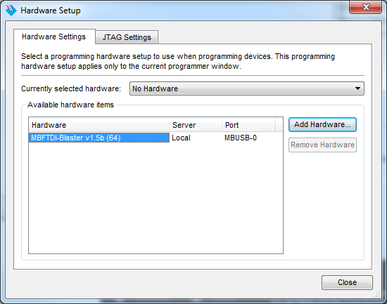

Double click on **MBFTDI-Blaster…** (where … is the version number and driver type) followed by close to select the programmer.

## Programming

The following procedure takes place in the Quartus Programming Window. The Hardware Setup must have already been performed prior to executing this procedure.

1. Use  to select a pof file to be programmed.
2. Check Program/Configure, Verify, and Blank-Check

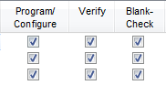

1. Press  to begin programming the selected file.
   1. The progress bar will indicate programming status.
   2. If the progress bar indicates  make sure the CPLD board is properly powered, and that the programming cable is properly attached. Then attempt to program again.